**Exercise 1 :**

**Example.java**

package com.example;

public class Example {

public int add(int a, int b) {

return a + b;

}

}

**ExampleTest.java**

package com.example;

import org.junit.Test;

import static org.junit.Assert.*;

public class ExampleTest {

@Test

public void testAdd() {

Example example = new Example();

int result = example.add(2, 3);

assertEquals(5, result);

}

}

**Output :**

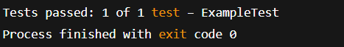

**Exercise 3 :**

**Output :**

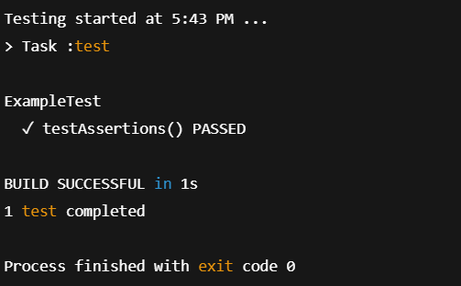

**Exercise 4 :**

**Calculator.java**

public class Calculator {  
  
 public int add(int a, int b) {  
 return a + b;  
 }  
  
 public int subtract(int a, int b) {  
 return a - b;  
 }  
  
 public int multiply(int a, int b) {  
 return a * b;  
 }  
  
 public int divide(int a, int b) {  
 if (b == 0) throw new ArithmeticException("Cannot divide by zero");  
 return a / b;  
 }  
}

**CalculatorTest.java**

import org.junit.After;  
import org.junit.Before;  
import org.junit.Test;  
import static org.junit.Assert.*;  
  
public class CalculatorTest {  
  
 private Calculator calculator;  
  
 @Before  
 public void setUp() {  
 calculator = new Calculator();  
 System.*out*.println("Setup done");  
 }  
  
 @After  
 public void tearDown() {  
 calculator = null;  
 System.*out*.println("Teardown done");  
 }  
  
 @Test  
 public void testAddition() {  
 int result = calculator.add(10, 5);  
 *assertEquals*(15, result);  
 }  
  
 @Test  
 public void testSubtraction() {  
 int result = calculator.subtract(20, 8);  
 *assertEquals*(12, result);  
 }  
  
 @Test  
 public void testMultiplication() {  
 int result = calculator.multiply(4, 6);  
 *assertEquals*(24, result);  
 }  
  
 @Test  
 public void testDivision() {  
 int result = calculator.divide(20, 4);  
 *assertEquals*(5, result);  
 }  
  
 @Test(expected = ArithmeticException.class)  
 public void testDivisionByZero() {  
 calculator.divide(10, 0);  
 }  
}

**Output :**

